Module 6:
Online Shopping Cart
Jeremy Matthews
Colorado State University Global
CSC500– Principles of Programming
Dr. Douglas Mujeye
Due Date: 03/22/26

Online Shopping Cart
Source Code
import math
from datetime import date, datetime

class ItemToPurchase:
def __init__(self, item_name="none", item_price=0.0, item_quantity=0, item_description="none"):
self.item_name = item_name
self.item_price = item_price
self.item_quantity = item_quantity
self.item_description = item_description

@property
def item_name(self):
return self._item_name

@item_name.setter
def item_name(self, value):
if not isinstance(value, str):
raise TypeError("Item name must be a string.")
self._item_name = value

@property
def item_price(self):
return self._item_price

@item_price.setter
def item_price(self, value):
if not isinstance(value, (int, float)):
raise TypeError("Item price must be a number.")
if value < 0:
raise ValueError("Price cannot be negative.")
self._item_price = float(value)

@property
def item_quantity(self):
return self._item_quantity

@item_quantity.setter
def item_quantity(self, value):
if not isinstance(value, int):
raise TypeError("Item quantity must be an integer.")
if value < 0:
raise ValueError("Quantity cannot be negative.")
self._item_quantity = value

@property
def item_description(self):
return self._item_description

@item_description.setter
def item_description(self, value):
if not isinstance(value, str):
raise TypeError("Item description must be a string.")
self._item_description = value

def print_item_cost(self):
total = self.item_price * self.item_quantity
print(f"{self.item_name} {self.item_quantity} @ ${self.item_price:.2f} = ${total:.2f}")

class ShoppingCart:
def __init__(self, customer_name="none", current_date="January 1, 2020"):
self.customer_name = customer_name
self.current_date = current_date
self.cart_items = []

def _find_item(self, item_name):
"""Return the first item matching item_name, or None."""
return next((item for item in self.cart_items if item.item_name == item_name), None)

def add_item(self, item):
if self._find_item(item.item_name):
print(f"'{item.item_name}' already in cart. Use change quantity option to modify.")
return
self.cart_items.append(item)

def remove_item(self, item_name):
found = self._find_item(item_name)
if found:
self.cart_items.remove(found)
print(f"'{item_name}' removed from cart.")
else:
print("Item not found in cart. Nothing removed.")

def modify_item(self, modified_item):
found = self._find_item(modified_item.item_name)
if not found:
print("Item not found in cart. Nothing modified.")
return
if modified_item.item_description != "none":
found.item_description = modified_item.item_description
if not math.isclose(modified_item.item_price, 0.0):
found.item_price = modified_item.item_price
if modified_item.item_quantity != 0:
found.item_quantity = modified_item.item_quantity

def get_num_items_in_cart(self):
return sum(item.item_quantity for item in self.cart_items)

def get_cost_of_cart(self):
return sum(item.item_price * item.item_quantity for item in self.cart_items)

def print_total(self):
print(f"{self.customer_name}'s Shopping Cart - {self.current_date}")
print(f"Number of Items: {self.get_num_items_in_cart()}")
print()
if not self.cart_items:
print("SHOPPING CART IS EMPTY")
else:
for item in self.cart_items:
item.print_item_cost()
print()
print(f"Total: ${self.get_cost_of_cart():.2f}")

def print_descriptions(self):
print(f"{self.customer_name}'s Shopping Cart - {self.current_date}")
print()
print("Item Descriptions")
for item in self.cart_items:
print(f"{item.item_name}: {item.item_description}")

def get_item_input():
"""Prompt user for all item fields and return a populated ItemToPurchase."""
new_item = ItemToPurchase()

while True:
new_item.item_name = input("Enter the item name:\n").strip()
if new_item.item_name:
break
print("Item name cannot be empty.")

new_item.item_description = input("Enter the item description:\n").strip()

while True:
try:
new_item.item_price = float(input("Enter the item price:\n"))
break
except ValueError:
print("Please enter a valid, non-negative number for the price.")

while True:
try:
new_item.item_quantity = int(input("Enter the item quantity:\n"))
break
except (ValueError, TypeError):
print("Please enter a valid, non-negative integer for the quantity.")

return new_item

def print_menu(cart):
menu = (
"\nMENU\n"
"a - Add item to cart\n"
"r - Remove item from cart\n"
"c - Change item quantity\n"
"i - Output items' descriptions\n"
"o - Output shopping cart\n"
"q - Quit\n"
)

try:
while True:
print(menu)
choice = input("Choose an option:\n").strip().lower()

if choice == "q":
break

elif choice == "a":
print("\nADD ITEM TO CART")
new_item = get_item_input()
cart.add_item(new_item)

elif choice == "r":
print("\nREMOVE ITEM FROM CART")
item_name = input("Enter name of item to remove:\n").strip()
cart.remove_item(item_name)

elif choice == "c":
print("\nCHANGE ITEM QUANTITY")
modified_item = ItemToPurchase()

while True:
modified_item.item_name = input("Enter the item name:\n").strip()
if modified_item.item_name:
break
print("Item name cannot be empty.")

while True:
try:
modified_item.item_quantity = int(input("Enter the new quantity:\n"))
break
except (ValueError, TypeError):
print("Please enter a valid, non-negative integer for the quantity.")

cart.modify_item(modified_item)

elif choice == "o":
print("\nOUTPUT SHOPPING CART")
cart.print_total()

elif choice == "i":
print("\nOUTPUT ITEMS' DESCRIPTIONS")
cart.print_descriptions()

else:
print("Invalid option. Please choose a valid menu option.")
except (EOFError, KeyboardInterrupt):
print("\nExiting.")

if __name__ == "__main__":
while True:
customer_name = input("Enter customer's name:\n").strip()
if customer_name:
break
print("Customer name cannot be empty.")

while True:
date_input = input("Enter today's date (MM/DD/YYYY) or press Enter for today's date:\n").strip()
if not date_input:
current_date = date.today().strftime("%B %d, %Y")
break
try:
parsed_date = datetime.strptime(date_input, "%m/%d/%Y")
current_date = parsed_date.strftime("%B %d, %Y")
break
except ValueError:
print("Invalid date. Please use MM/DD/YYYY format (e.g., 01/01/2020).")

print()
print(f"Customer name: {customer_name}")
print(f"Today's date: {current_date}")

cart = ShoppingCart(customer_name, current_date)

print_menu(cart)

Screenshots
Application Executing Program
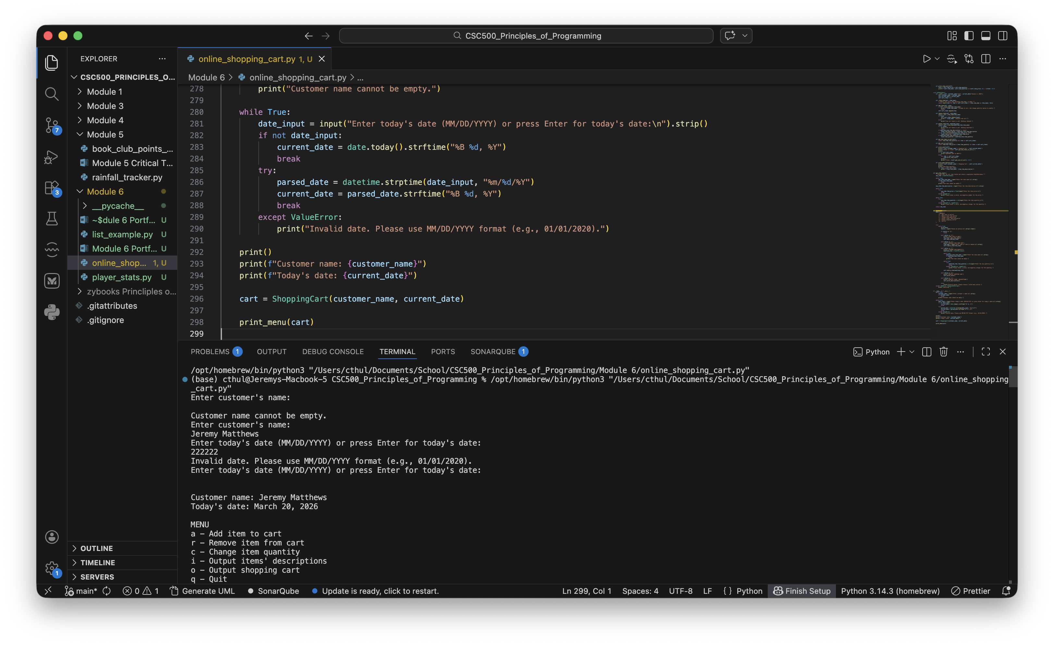

Results
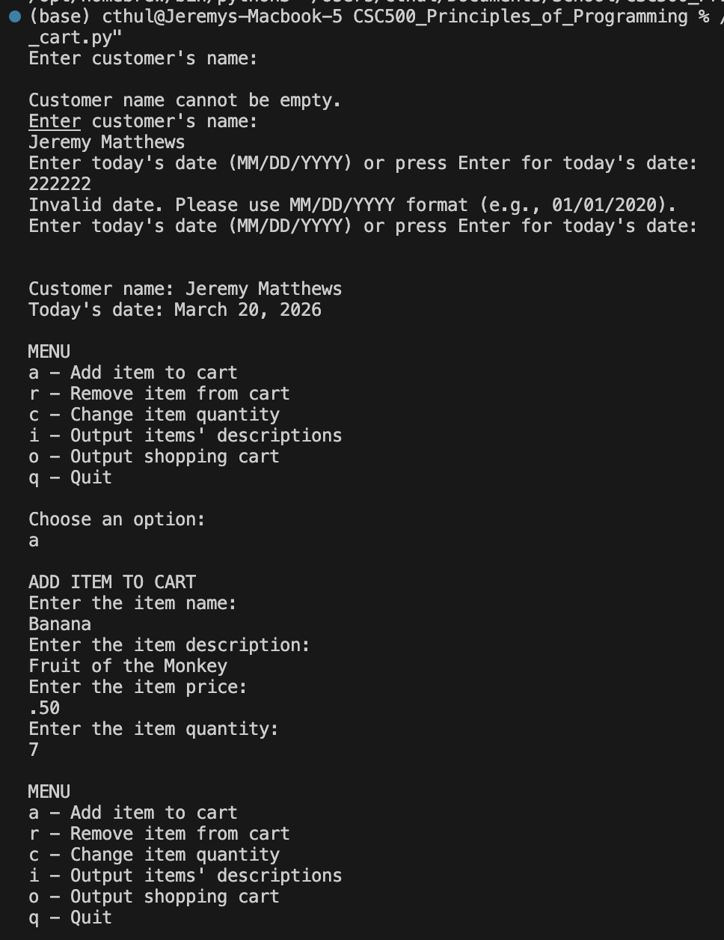
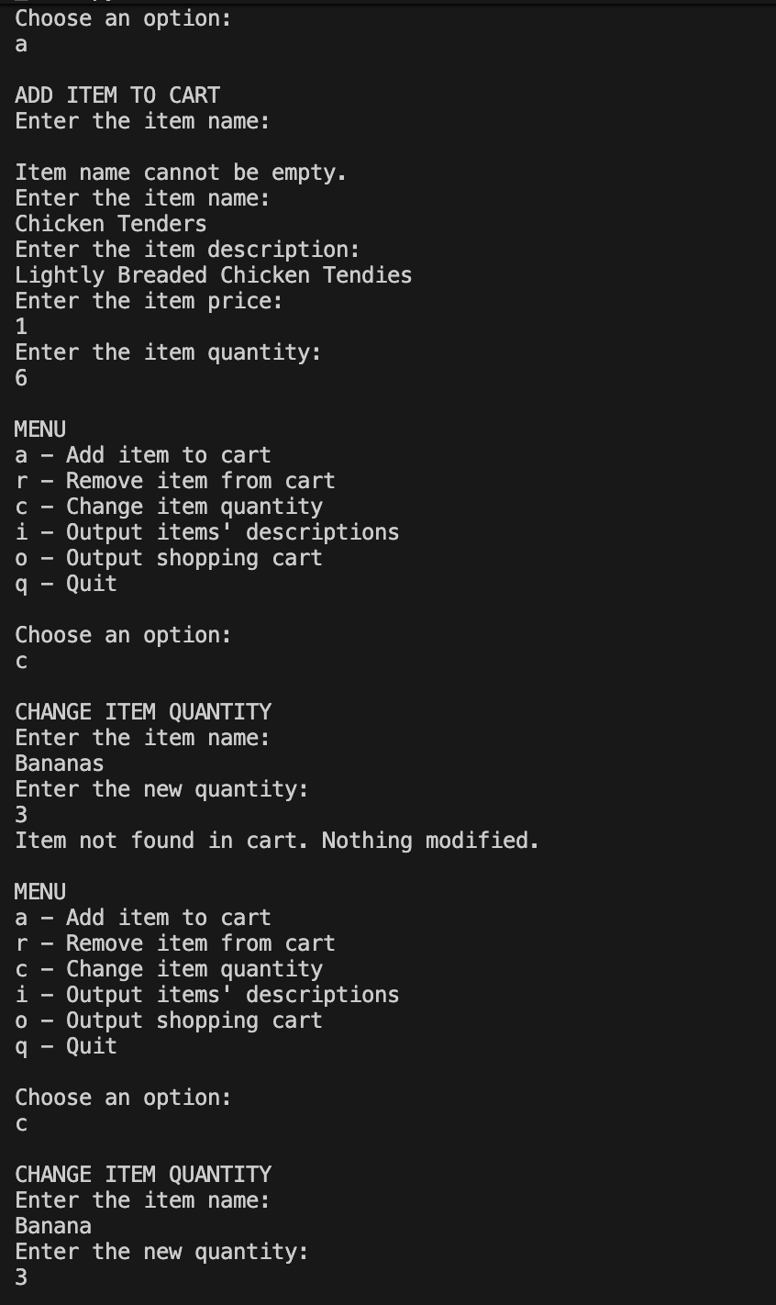
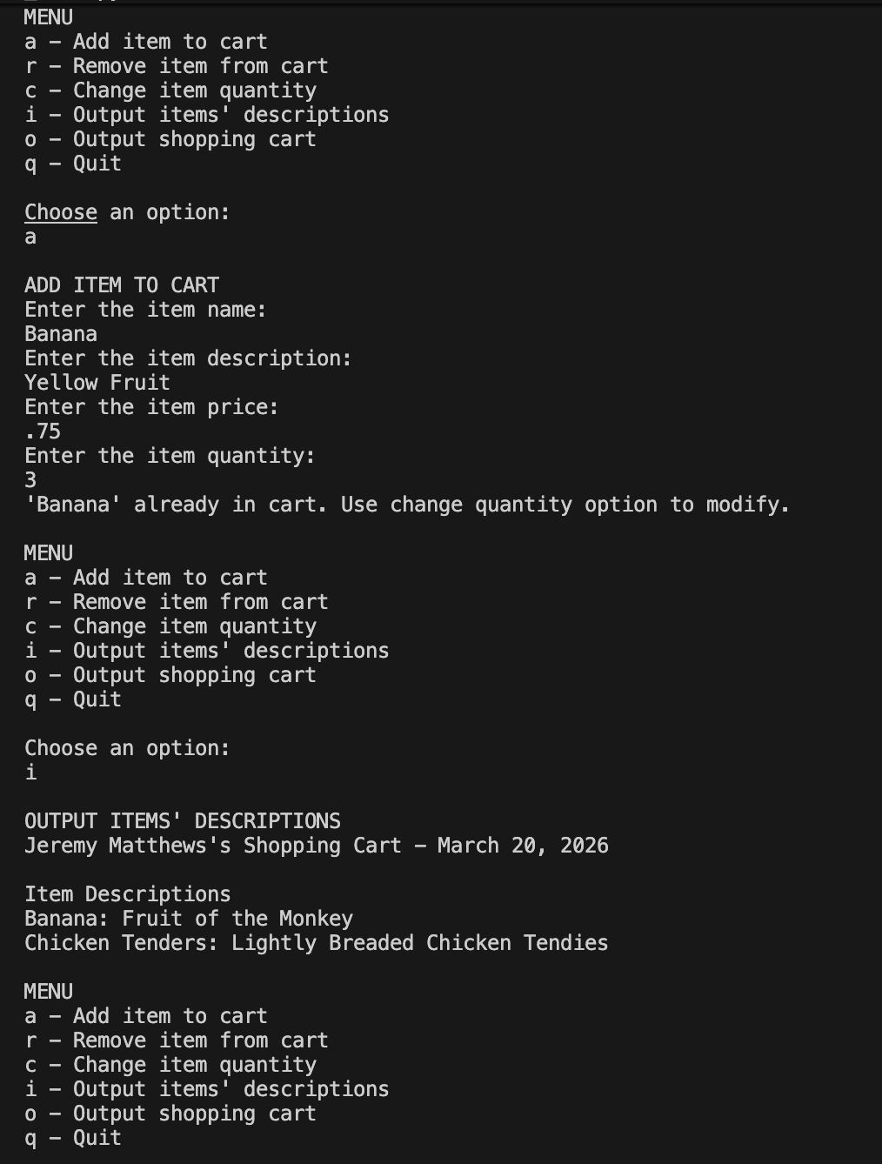
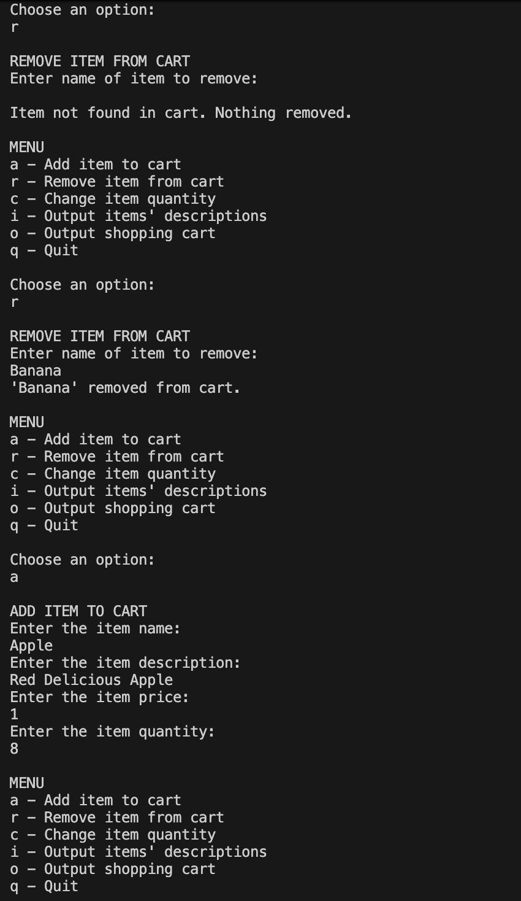
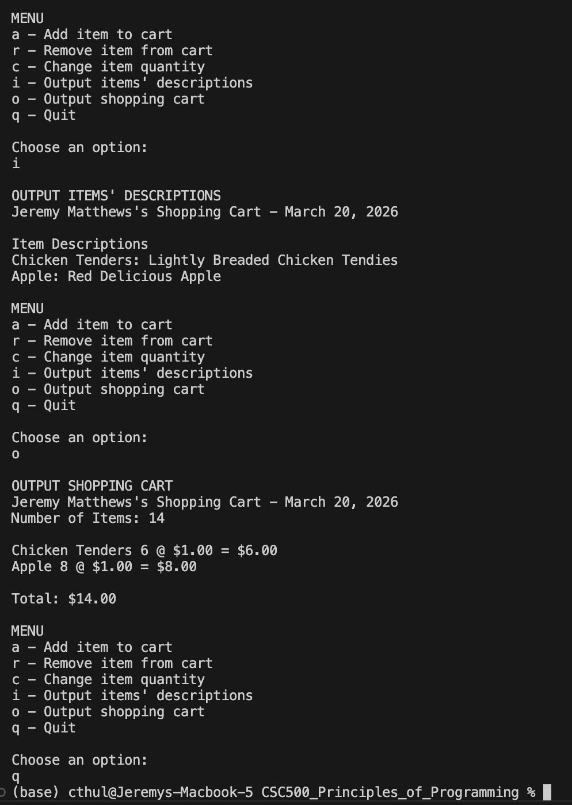
Github Repository
https://github.com/m9dful1/CSC500_Principles_of_Programming/tree/main/Module%206

